Science Gr.9 Exams Review & Study Sheets
(Made easy for you)

Outline of the Exam. Note that a larger version of the outline was handed out in class.
- Biology- Reproduction, microscope, cell cycle, pregnancy & birth, biotechnology, DNA.
- Chemistry- WHMIS, classify matter, Phys. And Chem. Properties, gas tests, theories & diagrams, atoms, etc.
- Physics- electricity- Terms, formula’s, circuits, graphing, measuring in units. Energy cost & efficiency, series and parallel circuits. .
40 Multiple questions, 30 Matching and 4 pages of short answer questions.

Biology
Microscope review.

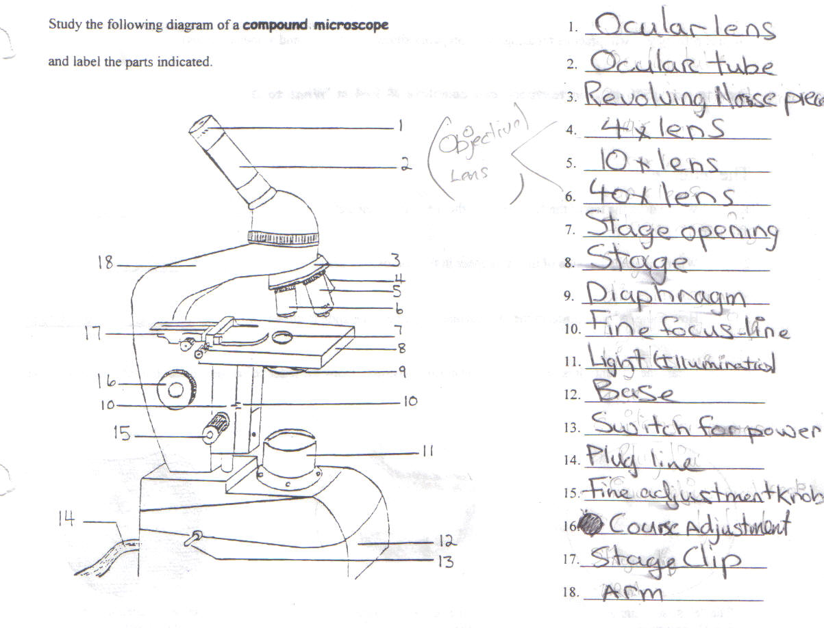

Revolving nose piece

11.Light source

5 important rules when using microscope in lab.
- Hold microscope with two hands, one on the arm and other on the base
- Never use the 100x lens.
- Always have it on lowest magnification.
- Leave stage on lowest position.
- Always check if fine focus line is in middle.

Function of each piece of a compound microscope.
Microscope part | Function
Arm | Connects the base to the tube. Used for carrying
Base | To hold microscope in place.
Ocular tube(Body tube) | Holds the ocular lens in place as well as the eyepiece and to keep a proper distance from each objective lens
Diaphragm | Controls amount of light coming in.
Ocular lens ( eyepiece) | Goes by 10x magnification
Fine adjustment knob | Medium and high power magnification.
High-power objective lens | X 40 of Magnification
Lamp | Illuminating parts
Low-power objective lens | X10 Of magnification
Mirror | Illuminate object or light
Revolving nose piece | To move the objective lens
Stage | holds the clips & specimen
Stage clips | To hold specimen in place
Stage opening | To let light in.

The Cell: Scientists
Scientist | Year | Nationality | Contribution
Robert Hooke | 1665 | English | Magnification reveals empty room like compartments or cells
Anton Van | 1674 | Dutch | Built microscopes; discovered microscopic organisms
Robert Brown | 1831 | Scottish | Was the first to consider the nucleus as a regular part of a living cell.
Felix Dujardin | 1838 | German | All plants are made of cells.
Theodore  Schwan | 1839 | German | All animals are made of cells
Virchow | 1858 | German | Cells are the last link in a great chain that forms tissue, organs, systems and individuals.

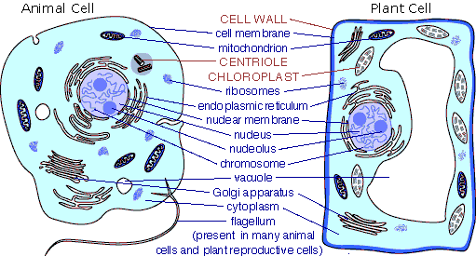

Organelle | Description | Function
Nucleus | Spherical or oval body usually near the center of the cell ( Largest organelle)  Appears as a large dark staining structure. | Control Center of all cell processes.  Contains the information to regulate the growth and reproduction of the cell
Nuclear membrane | Covers the outside of the nucleus. | Encloses the cells genetic material & DNA
DNA | Deoxyribonucleic acid  Long strands of chromatin  Found in the nucleus core. | DNA holds the instructions to assemble the necessary substances for building the cell and making it work.
Chromatin | Long strands of DNA scattered throughout a cell & nucleus. | Holds all pieces of DNA together.
Nucleolus | A small, typically round granular body composed of protein and RNA in the nucleus of a cell. | Manufactures ribosome parts.
Ribosomes | Small, tiny, granular, cell structures RNA & DNA. | Its involved in the manufacturing of proteins.
Cell membrane | Selectively permeable structure | Encloses contents of the cell
Cytoplasm | A jelly like material enclosed by cell membrane – often moving | It supports the nucleus & organelles.
Endoplasmic reticulum | A folded membrane look likes a series of canals. | Forms a series of canals.
Mitochondria | A rounded piece in the cell | Transform energy for the cell.  Gives energy for cell activities.
Golgi bodies | A package with useful materials. | This package, packages the materials inside and moves them out of cell.
Vacuoles | It is a part of the cell that contains water. | Its contains good wastes and other materials like a container.
Lysosomes | Spherical organelle by a single membrane. Membrane can resist enzymes. | Its breaks down food and digests waste and worn out cell parts.
Cell wall | The outer layer of the cell. Note: Only plant cell’s have these. | It protects the cell by holding extra water and only allowing in what is needed.
Chloroplasts | An organelle that contains chlorophyll. | Enables plants to make carbohydrate through the process of photosynthesis.
Comparing Plant and Animal cells.
- Plants get their green colour from chloroplasts, which are found in organelles called chlorophyll.
- Within the chloroplasts, carbon dioxide and water are chemically combined to form oxygen.
- C0₂ is formed by a process called photosynthesis.
- Plant cells have centrioles whereas cells of animals usually do not.
- Vacuoles are larger in plant cells whereas animal cells usually have several small vacuoles.
- Lysosomes contain digestive enzymes.
- Plant cells have a cell wall which provides support
- The cell membrane controls what enters or leaves a cell.
- The state of balance within a cell is referred to as homeostasis.

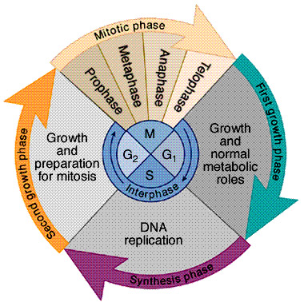
Cell Cycle
Stage 1 Interphase.
Phase 1 Rapid growth: The cell is rapidly growing.
Phase 2 Growth and DNA Replication: For the two new cells (formed after division, now called daughter cells.), to carry out the activities necessary for life, they require the genetic information contained in the original nucleus.

Chromosomes have small parts called genes. Genes are made of a chemicals called DNA, genes always works in pairs.
Chromosomes contain genetic material, DNA: instructions needed to build a completely new organism from a single fertilized egg cell. Chromosomes always work in pairs.

DNA must be copied (replicated), so that when one cell divides into two cells each cell gets a copy of all the DNA, located in the nucleus.
Each thin strand of DNA called “ chromatin”, is copied or replicated, so that there are two sets of DNA.

The copies of chromatin stay uncoiled for a while. The replicated chromatin strands now coil into thick, large and dense double stranded chromosomes.
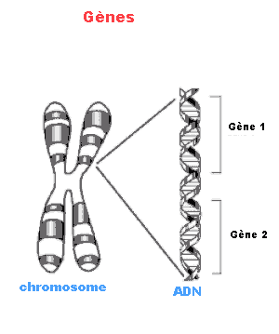
At this point, it is easier to see the chromosomes and the fact that they are joined together in the middle at a region called the Centromere. This attachment ensures that the chromatids will remain paired through the early phases of the cell divisions.

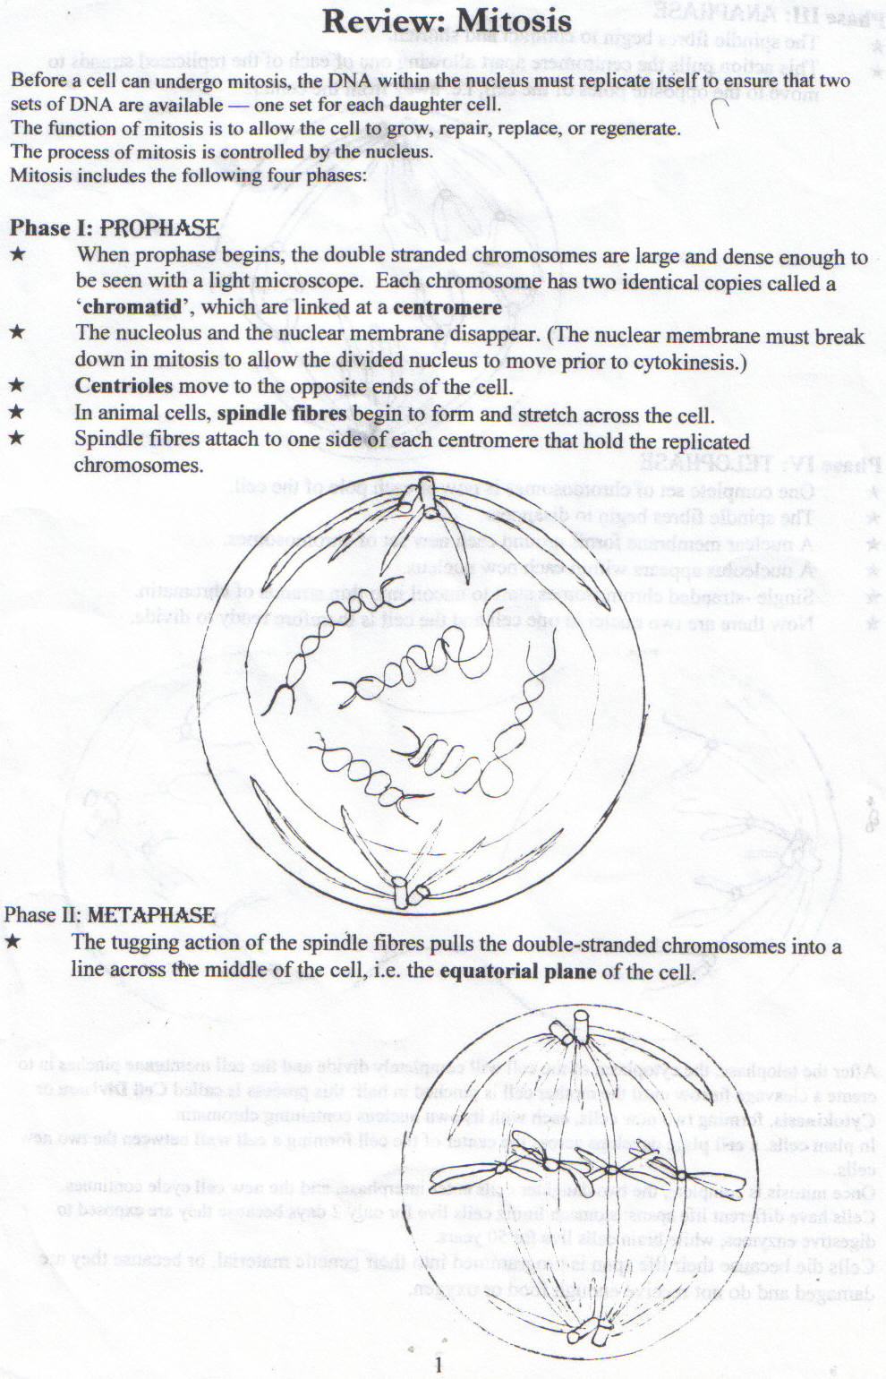

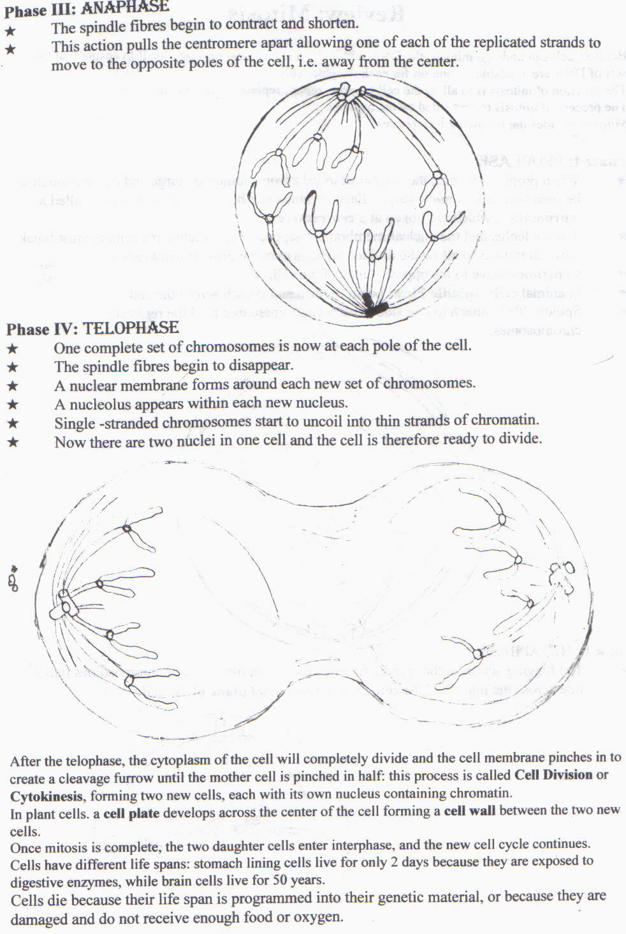
Asexual Reproduction
Asexual reproduction is the formation of a new individual that has identical genetic information to its parent.

Asexual Reproduction
Asexual reproduction is the formation of a new individual that has identical genetic information to its parent.
Advantages of asexual reproduction
- Does not require another individual.
- All organism to spread & occupy or invade habitats
- Speed of reproduction therefore requires less time & energy.
- High population from doubling up.
Disadvantages
- No genetic variability. Therefore off-springs exact replicas.
- More likely to go extinct. Therefore environmental conditions destroy the populations.

Difference Prokaryote cells and Eukaryote cells.
Eukaryote cells have a nucleus and prokaryotes do not have nucleus.

Kingdom Monera
Bacteria reproduce asexually by a process called binary fission. Binary fission is when a parent cell divides into two new cells containing a single chromosome and becoming a complete set of DNA.
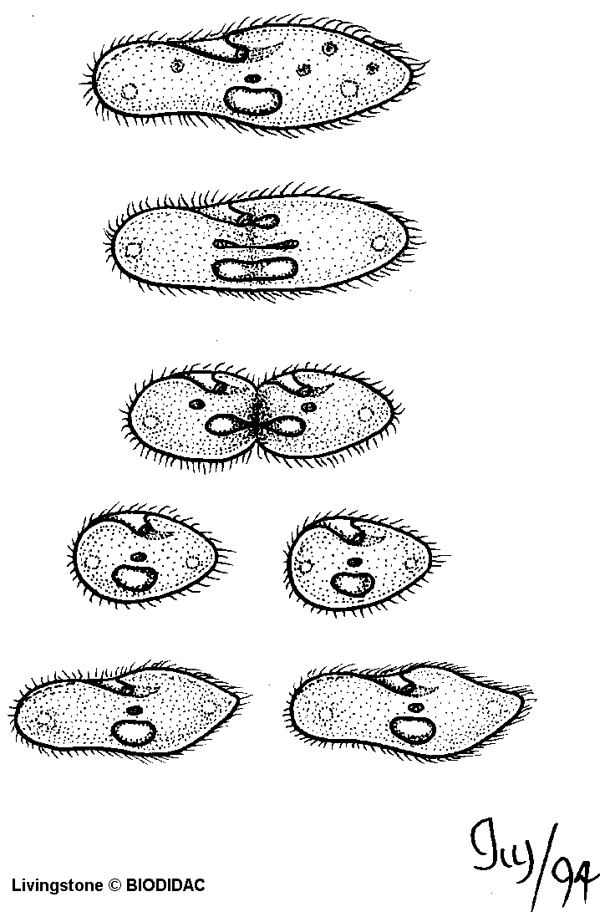
5 steps of binary fission.→
- Cell wall
- Chromosomes replicated
- Cell grows longer and chromosomes have opposite end of the cell.
- Cell membrane pinches in.
- A new cell wall forms and 2 new cells.
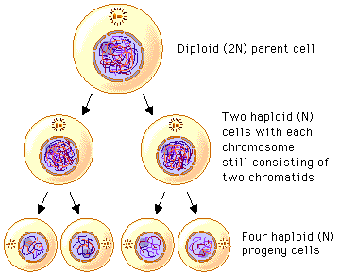

Kingdom Protista
Protists such as amoeba reproduce by mitotic cell division. Mitotic cell division is to form two identical off springs.
The difference between binary fission and mitotic cell division is binary fission uses the form of asexual reproduction when they do not a true nucleus and the nucleus is not to be divided.

Diagram of Kingdom Fungi:

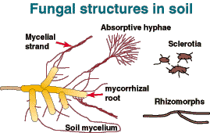

Kingdom Fungi

Organisms that make up the kingdom “fungi” are moulds, yeast and mushrooms. Fungi get their food from hyphae that grow over the surface into bodies of other organism.

Hyphae are filaments that make up the body of a fungus.

Kingdom Animalea
Invertebrates such as sponges, jellyfish, planaria and hydra can reproduce asexually.
Planaria: regeneration “growing new parts”

Sponges: Budding
Hydra: Budding
Sea stars: Regeneration
Animals reproduce asexually by budding. It forms a tiny bud on the cell wall following the division of the nucleus. The tiny bud continues to grow until it eventually breaks away → new independent cell.
Advantages of animals reproducing asexually:
1. It does not require another individual to complete the process.
2. Usually only takes a short period of time.

Method | Description | Example
Fragmentation | Small piece breaks away from the main mass of any hyphae grows into a new individual.  *Fragment must contain a nucleus. | Mushrooms
Budding | - Copy of nucleus is made.  - Tiny bud begins to form on the cell wall.  - Bud contains new nucleus.  - Eventually breaks off to become a new individual. | Yeast
Spores | Reproductive cell → new cell by mitotic cell division.  Spores stored in sporangium. | Mould

Fungi can both useful and harmful to humans. There are about 55 fungi that cause disease to humans. Egotism disease is caused from ingesting grains and cereals infected with the fungus Claviceps purpurea. In 1928 Fleming discovered a useful bacteria- Killing fungus which we call Penicillin.

Asexual Reproduction in plants
On a plant the growing areas on the tips of roots and stems are called meristem. Meristem is made up of un-specialized cells that undergo mitosis and cell division repeatedly producing cells.
At a certain point in a cells growth, meristem cells specialize into the cells that make up the roots, the stems and the leaves of the plant.
Techniques and methods to increase number of plants
- A technique for increasing number of plants is propagating.
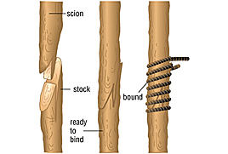
- Another way of increasing number of plants is cloning by creating an identical offspring from a single cell.
- Method of extending or adding a new stem is layering.
- Layering is a branch of the parent plant is bent down into the ground and part of it is cover with soil. Tips of the plant will shoot up and grow.
- A common technique used is grafting, the transplantation of living tissue from one individual to another or to a different location on the same individual.
- Tissue culture is a way to speed up the growth and economics of the plant.

Sexual Reproduction
In Animals
The cycle that allows animals reproduces sexually.
- Sperm and egg (23 gametes) → Sperm penetrates the egg and fertilization occurs→Fertilized egg (46)→growth and development→ Embryo (46) The embryo develops through mitosis and cell division.→growth and development →Meiosis occurs in the gonads of male and female parents to produce gametes.
External fertilization
External fertilization is when sperm and egg meet outside the bodies of both parents. Commonly found in water-dwelling animals such as frogs and fish.
Cycle- External fertilization sperm penetrates egg→Zygote→hollow ball of dividing cells→ free swimming larva→ attached, non-feeding form → able to catch and consume prey→adults→ Male and female gametes are released.
Internal fertilization
Internal fertilization is when males transfer sperm into the female’s cloaca, a chamber where the reproductive, urinary and digestive ducts leave body. The sperm travel up the reproductive duct to meet the eggs from female’s ovary.
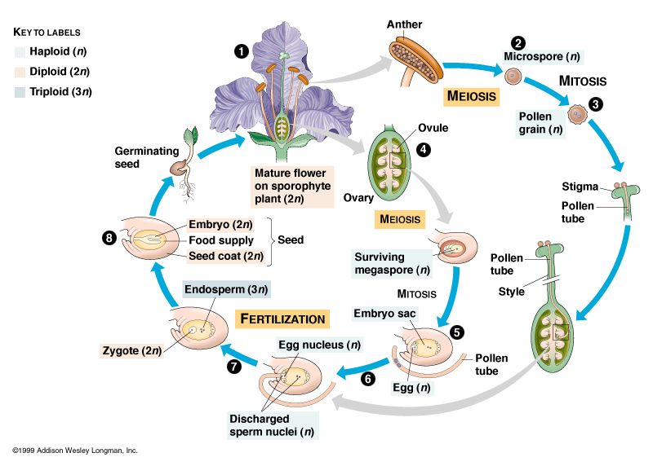
In Plants

Name of plant part | Function of plant part
Anther | Where pollen is produced and stored
Pollen grains | Cases containing male gametes
Filament | Stalk that supports the anther
Stigma | Sticky “lip” of the pistil that captures pollen grains
Ovary | Swollen base of the pistil containing ovules
Ovules | Sac containing female gametes
Stamen | Male reproductive organ
Pistil | Female reproductive organ
Style | Stalk that supports the stigma

The cycle for sexually reproducing plants
1. Pollination occurs when a pollen grain lands on the stigma.
- A pollen tube grows down the style into the ovary and enters ovule.
- A sperm travels down the tube to fertilize one egg.
Key Terms:
Germination: the process in which a seed begin to grow.
Fertilisation: the process by which gametes.
Pollination: in a flower, the process by which pollen grains from the anther reach stigma of the pistil.
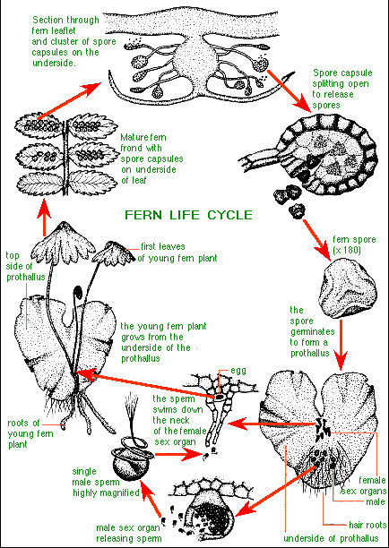
Implantation: the process by which a developing embryo becomes anchored to the lining of uterus.

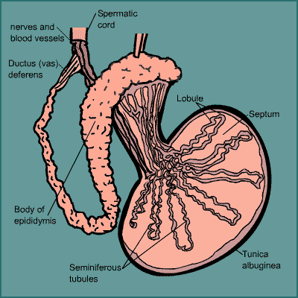
Review of Male Reproductive Anatomy

Vas deferens: either of two tubes that transport sperm from the epididymis to the urethra.
Epididymis: A structure next to the testes, where sperm is stored
Prostate Gland: A gland near the upper end of the male urethra; it produces fluids found in semen.
Seminal Vesicles:
Urethra:
Semen:

The main function of the male reproductive system is to produce sperm.
The main organs of male reproductive system are testes and the penis.
The main function of the testes is to produce and store sperm.
The function of the sperm is to fertilize a females egg.
The main reproductive of function of the penis is to provide a structure by which sperm may leave the male body and enter female body, so that sperm may carry out their function.

Testis → Epididymis → Vas deferens → Urethra → Out of body

Production of sperms in the seminiferous tubules of the testes move into the epididymis travel to vas deferens continue along the urethra than leaves the body.

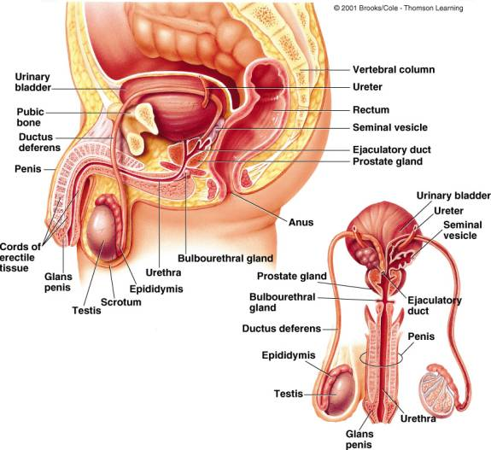

Review of Hormones
Hormone | Produced by | Function
FSH | Pituitary | To simulate the development of egg cells in females and sperm cells in male
Estrogen | Ovary | Stimulating the pituitary in the bloodstream.
Estrogen | Ovary | Travels to the pituitary in the blood stream.
LH | Pituitary Gland | A pituitary hormone that promotes the production of egg cells by the ovaries
LH | Pituitary Gland | Development of the corpus luteum.
Progesterone | Corpus luteum | Increases the thickening of uterine lining.
Progesterone | Corpus luteum | Rising levels of progesterone in the bloodstream causes the pituitary to decrease its production of FSH & LH
Progesterone | Corpus luteum | Decreasing FSH & LH prevent more egg cells from being released until progesterone levels decrease once again.

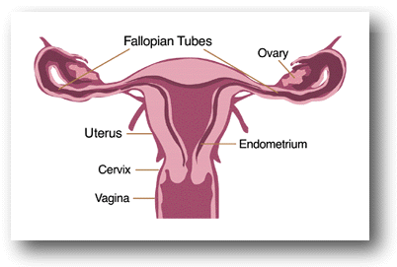

Fertilisation: The process by which gametes from two parents combine to for a new cell.

Ovulation: The process of releasing a mature egg from an ovary.
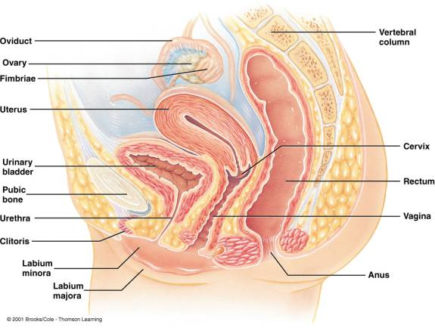
Menstruation: The monthly shedding of the uterine lining that occurs if fertilization has not occurred.

An egg can survive 13 days after ovulation and is released every 28 days.
The menstrual cycle takes place every month.

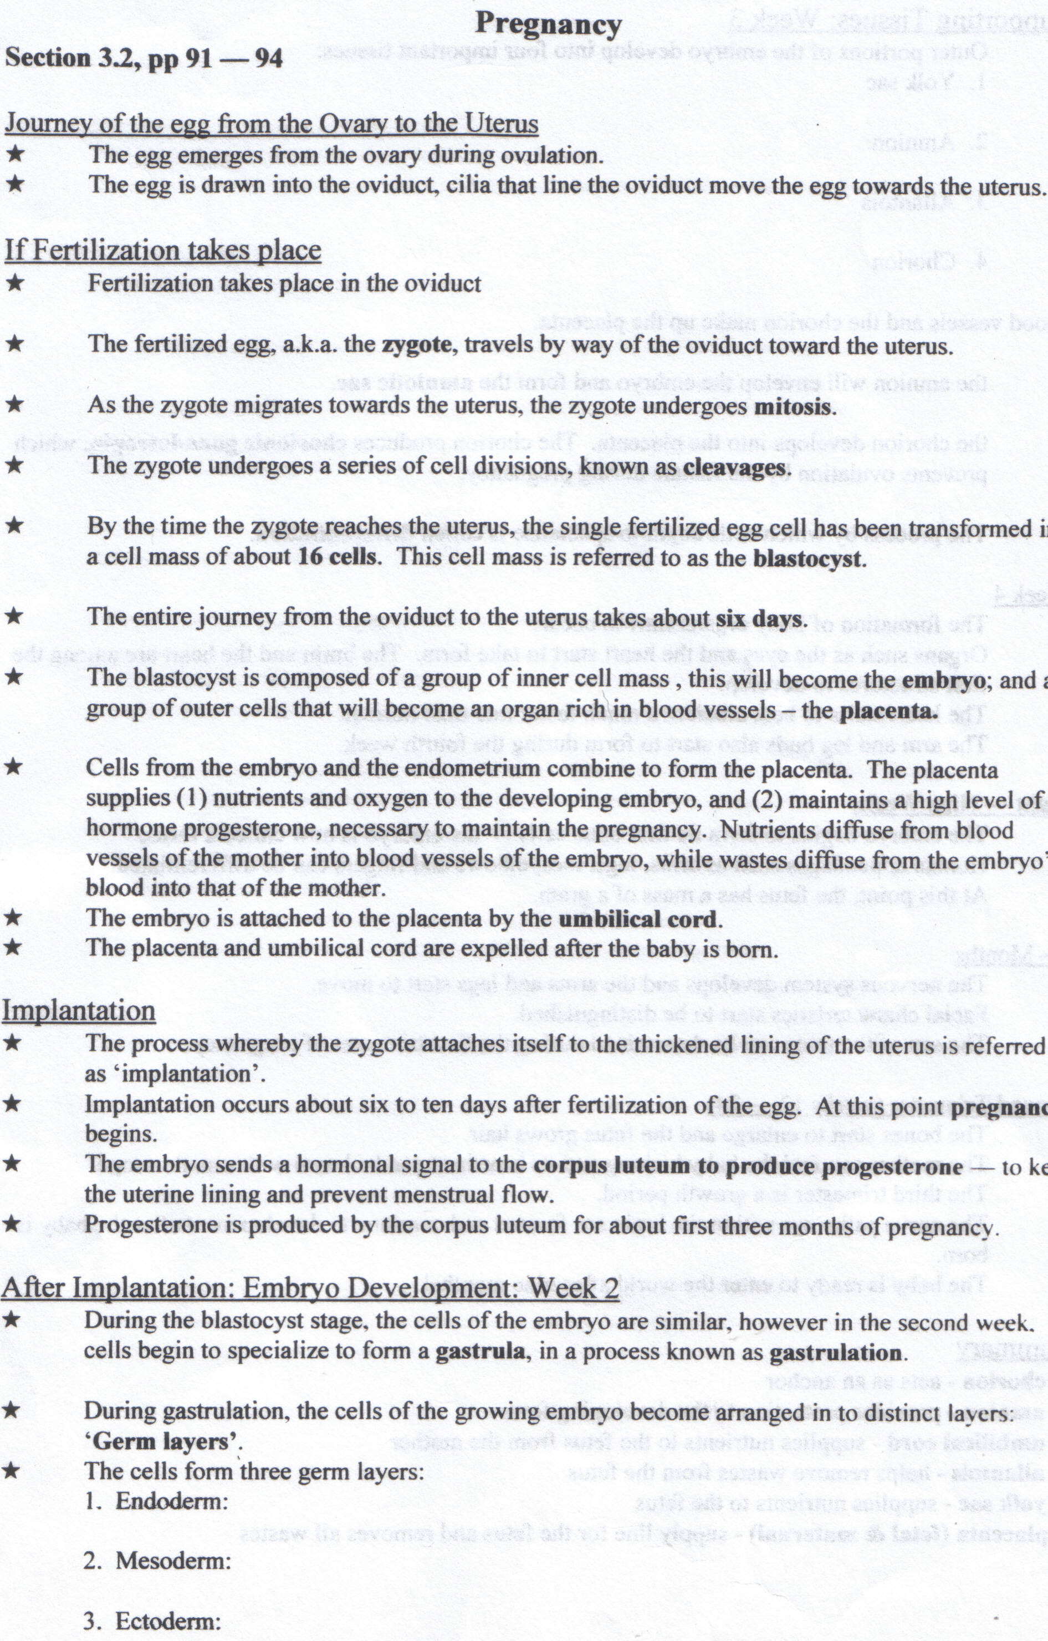

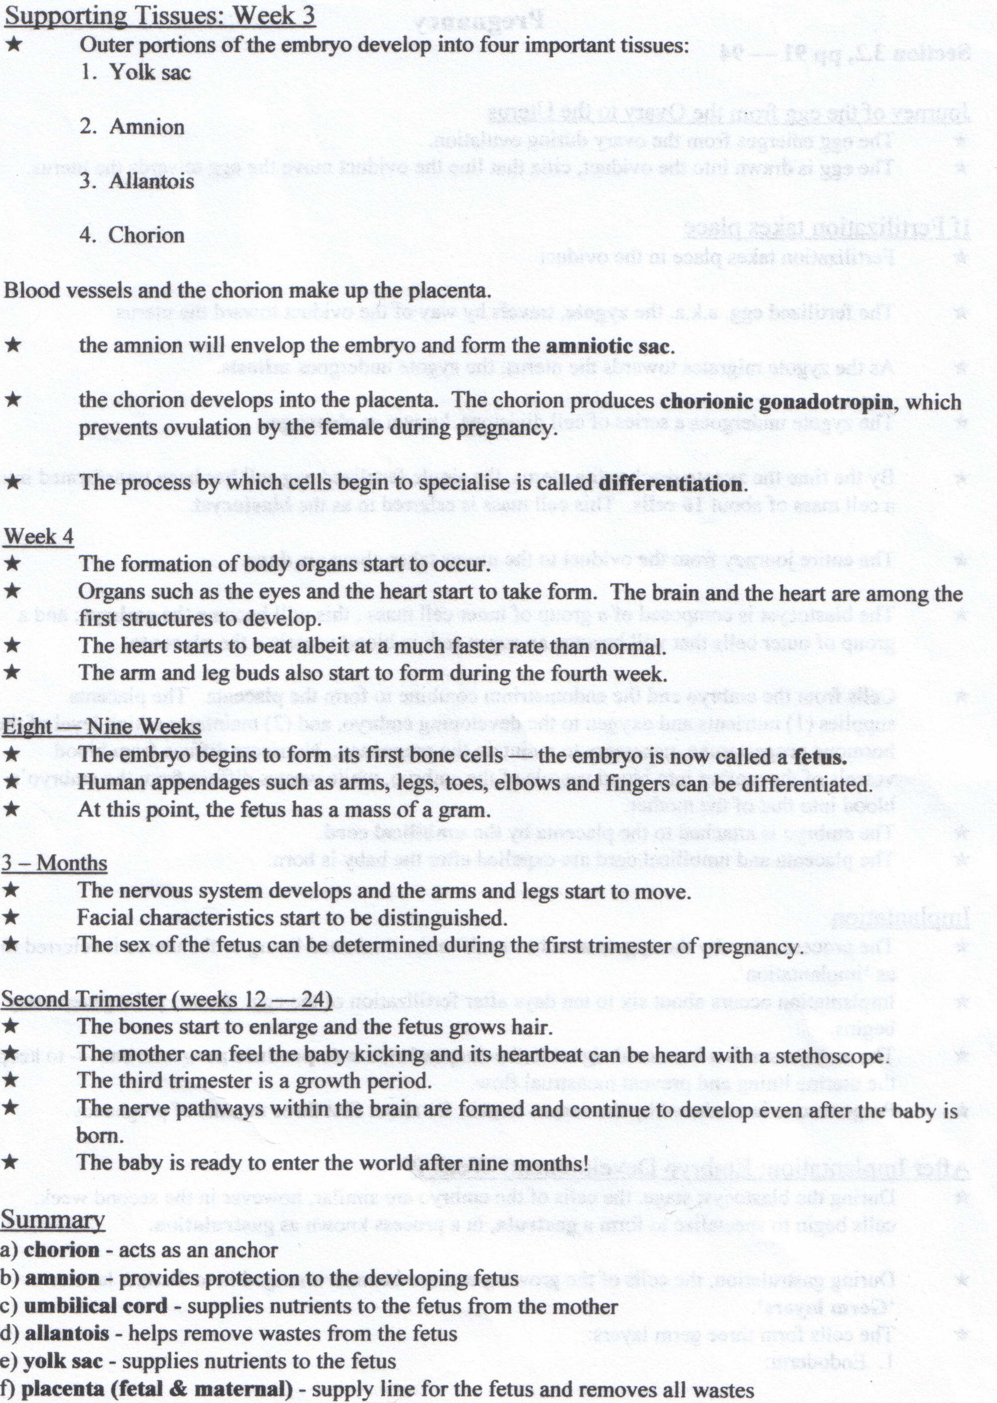

Birth
- Dilation stage uterine contractions and the hormone oxytocin cause the cervix to open or dilate. During this stage the amnion breaks and the amniotic fluid is released through the vagina. The dilation stage lasts an average of 2h to 20h.
- Expulsion stage: Contractions in the uterus become so forceful that the baby is pushed though the cervix to the birth canal. This takes from 0.5 to 2h. As the baby moves through the canal, its head rotates, making it easier for its body to pass through the birth canal.
- Placental stage: The placenta and umbilical cord are expelled from the uterus. This usually happens within 10 or 15 minutes after the baby is born. The expelled placenta is called the afterbirth.

Factors that affects birth.
  - Smoking and alcohol may affect the normal development of the fetus and can cause permanent damage.
  - Smoking constricts the foetus’s blood vessels, and prevents the baby from getting enough oxygen.
  - Alcohol affects the function of the brain, central nervous system and its physical development usually called Fetal Alcohol Syndrome, FAS.
  - Other factors are radiation from genetic material, mercury, toxicants, PCBs and mercury. These chemically can lead to cancer and other defects.
  - Certain drugs lead to deformities and missing body parts after a baby is born.
Biotechnology
Biotechnology is using or modifying living organism to produce marketable goods.
What is selective breeding?
Breeding individual with certain desired traits produces offspring with similar traits.
What is reproductive technology?
It is the knowledge of cell biology & DNA has developed into a specialized area of study.
DNA
DNA stands for deoxyribonucleic acid. A nucleotide is a segment of DNA composed of a sugar molecule.
4 nitrogen bases are adenine, thymine, cytosine and guanine.
Adenine and thymine fit together and cytosine and guanine go together.
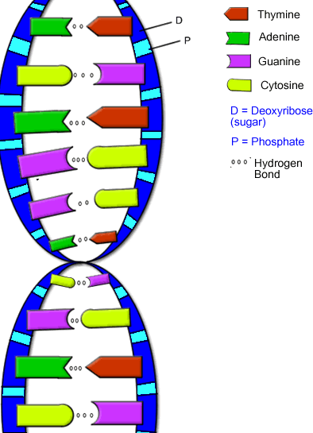
A codon is made up of 3 consecutive bases and has enough information to recognize a CTA amino acid.
DNA contains the message to make protein stringing together amino acids in order.
Proteins are molecules that make up most of the structure of cells and tissue and vital material such as enzymes and hormones.
Proteins are made up of amino acids. Each protein molecule is made up of 100’s or 1000’s of smaller molecules of amino acids.
A gene is a segment of DNA on a chromosome that code a particular protein.

